# User Manual

**Overview:**

Cocktail-World is the prefect application to help one find various information about the world of cocktails.

The website is a user-friendly environment, and is intuitive for one to navigate the features implemented.

In Cocktail-World you choose one of the information queries presented in the maiun screen that you would like to explore. After one is chosen, you enter input regarding the specific data that you want to be presented. Each query presents a different kind of information by design. Thus each one has a different input and output presentation.

**Screens of the application and guide to navigation:**

* **Explanations mainly on anything which isn’t intuitive**

The main screen, which you can always come back to is presenting a thumb line bar which you choose one of the few query features current available:

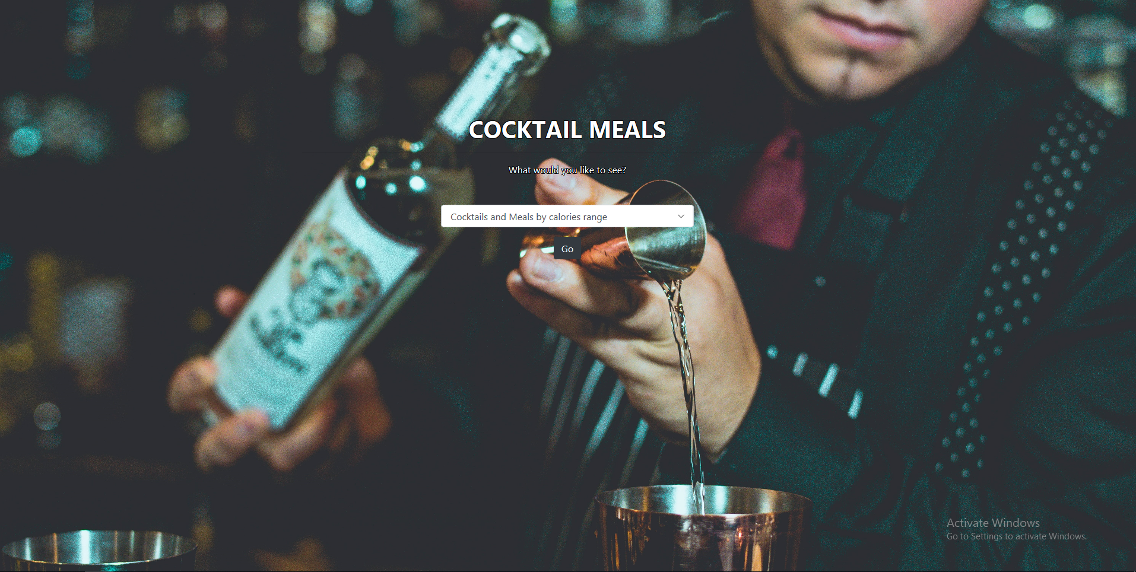

Next, choosing one of the things you currently want to explore:

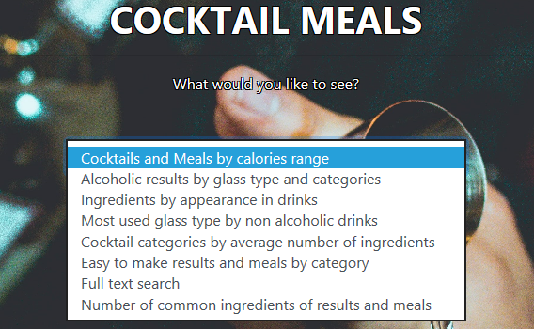

And then, using the “Go” button.

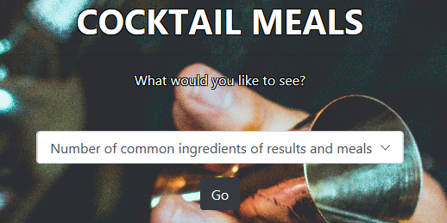

After choosing one, the latter is mainly consistent and has the following features:

* The example follows “number of common ingredients of drinks and meals”

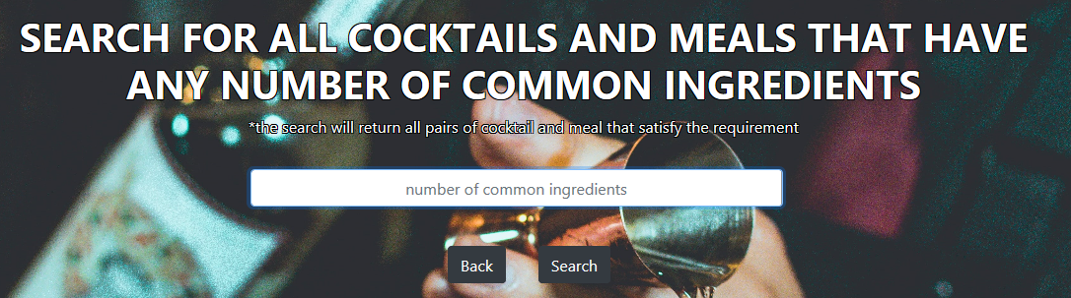

The latter has a box where the user enters his input (in this example ,only a number will return results)

You can always go back to the main screen using the “Back” button.

After entering a number and pressing “Search”, the data will be presented in the following screen:

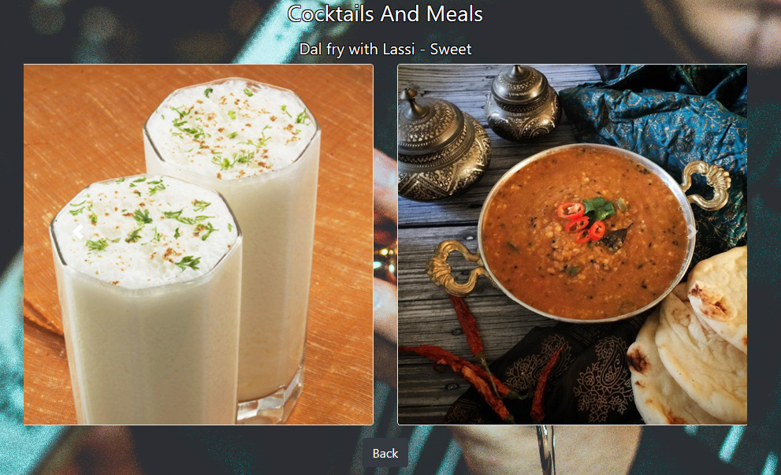

The screens that present data mainly has these features:

* A “Back” button, going back to the previous screen.
* 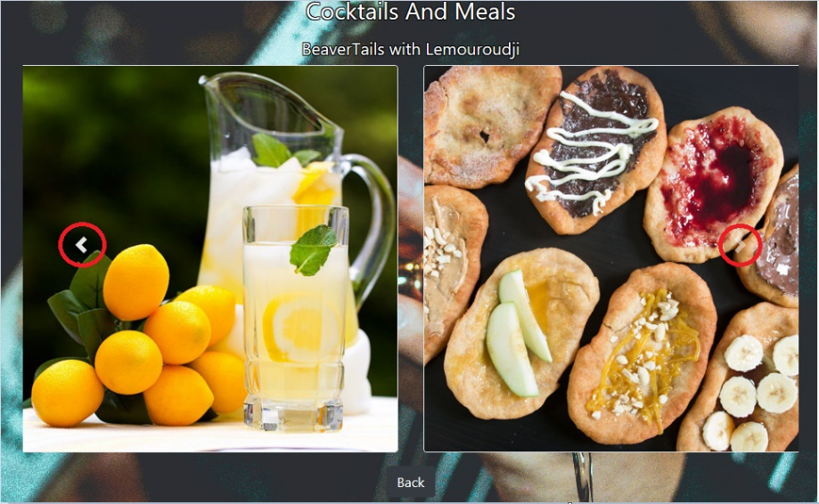2 arrows for traversing between the data (in this example, going between pairs of “meal and drink”)
* When pressing on a picture of a drink\meal, A new screen pops up with the relevant info on that food\drink (in the picture: Instructions + video of on how to make it)
* And again, a back button (to main screen) + “back to results” to keep scrolling on your data.

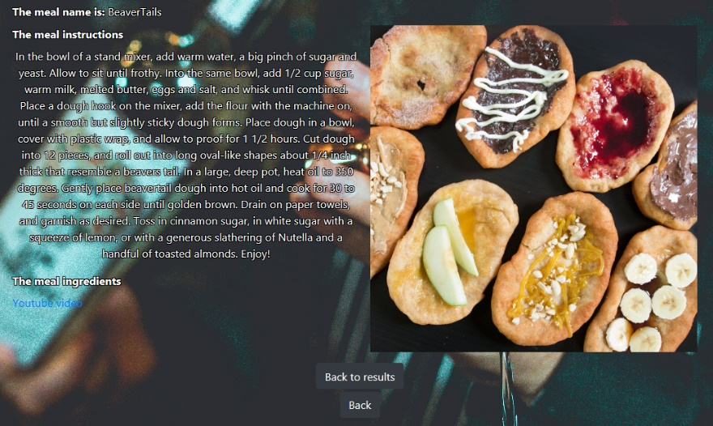

Another important to mention feature:

* When using a screen that asks for a category list to be used from the user, there is an implemented “auto-complete” function. Although, after clicking on an option, the user must choose **“Add Category”** before choosing another category, or pressing the “Search” button.

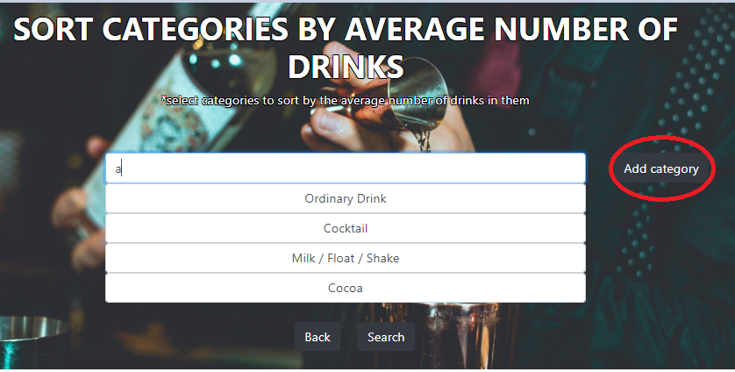

An example of the latter:

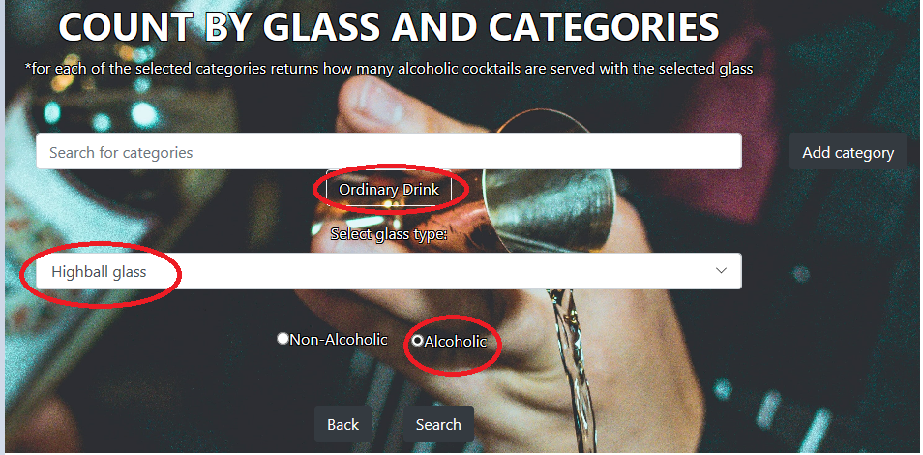

In this screen, the user chooses a category list , the glass the cocktail is served in, and if he wants an alcoholic or Non-Alcoholic drink. A valid “stage” to press “Search” would be after one of the [Alcoholic,Non-Alcoholic] is marked, atleast one category was chosen, and a glass type was chosen.

Searching for Ingredients

When a user uses a query that returns ingredients, the latter will be presented in the following manner:

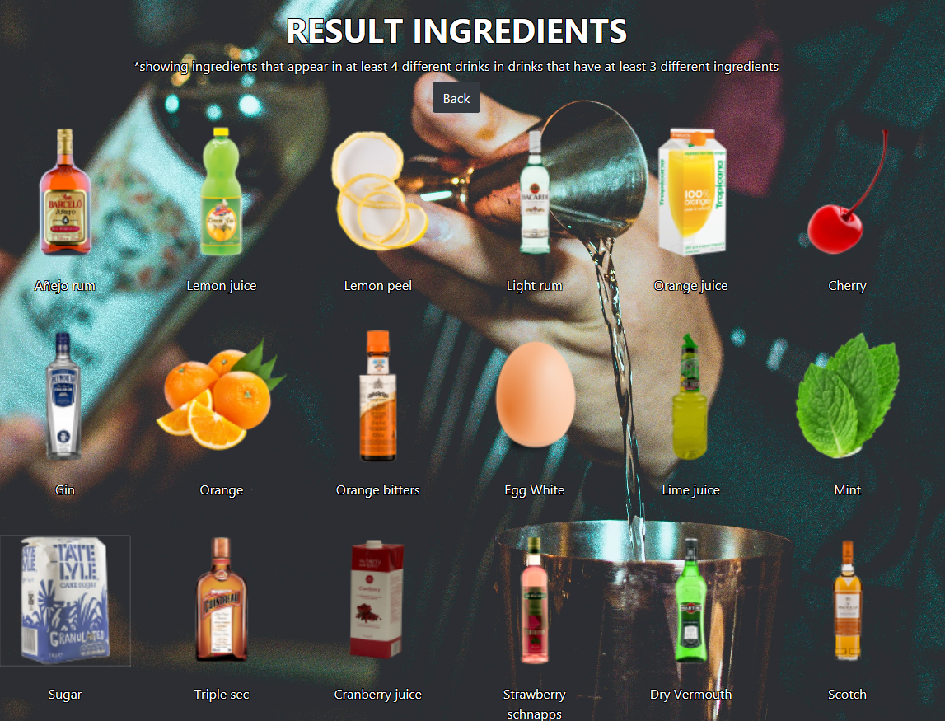

Full-Text Search

The full-text search we have searches through the instructions of meals\Drinks.

Therefore, a few suggestions to use for getting various results (when one isn’t very good with ingredients):

* Gin , tonic , vodka , egg , brandy , beverage , cocktail , meat , sour.